1030_PTR Enrollment initiated by EV for Combo customer
Contract No. 4013670272
Material No. 80010079
Serial No. 25177212
Equipment No. 100002881656
Contract Account. 100047520844
Functional Location. 6002276613

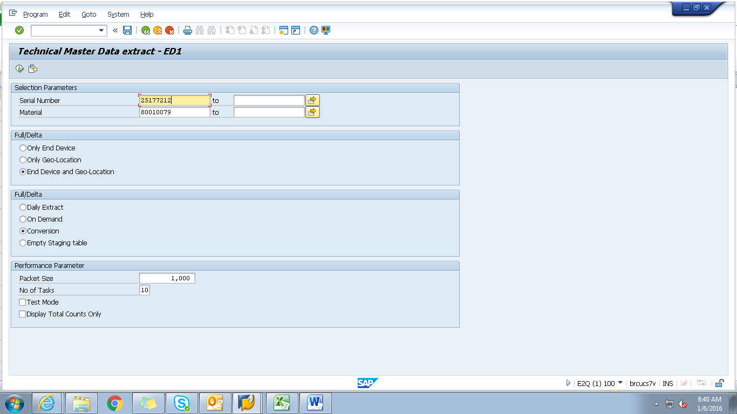

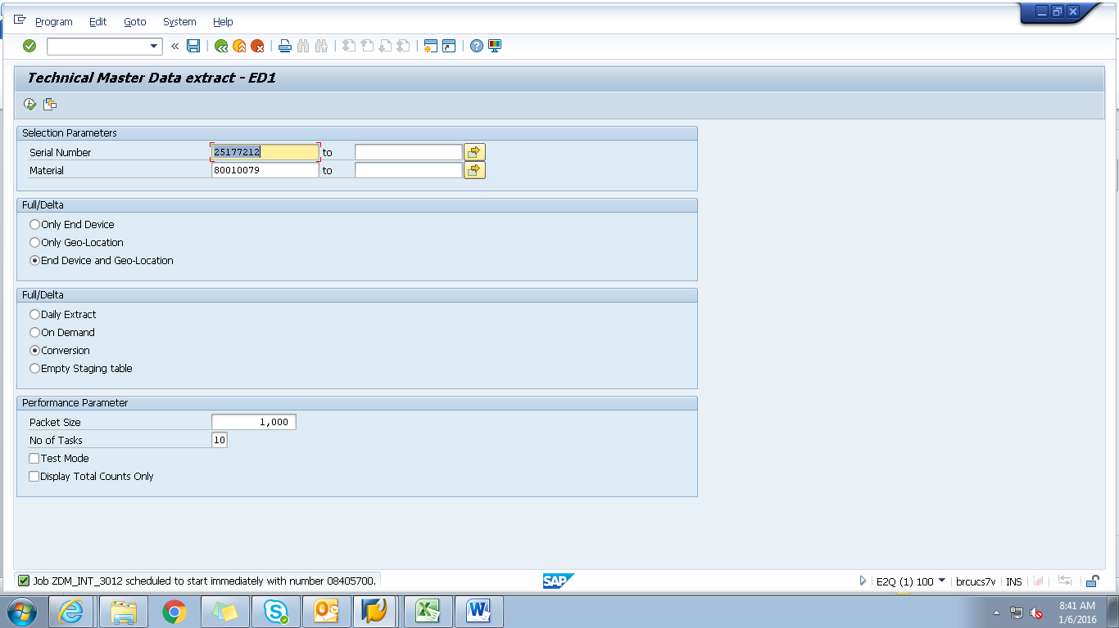

Spool
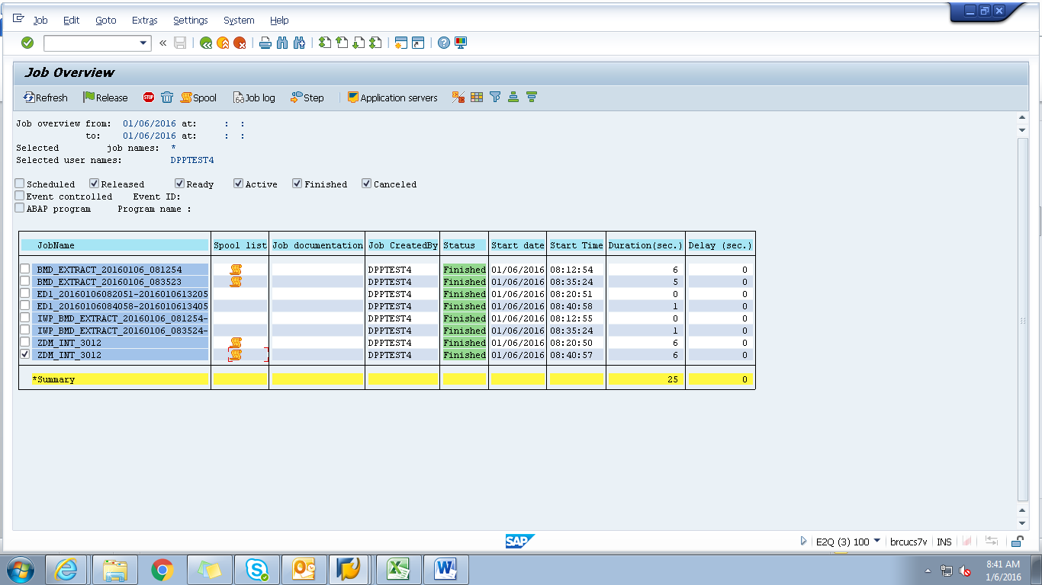
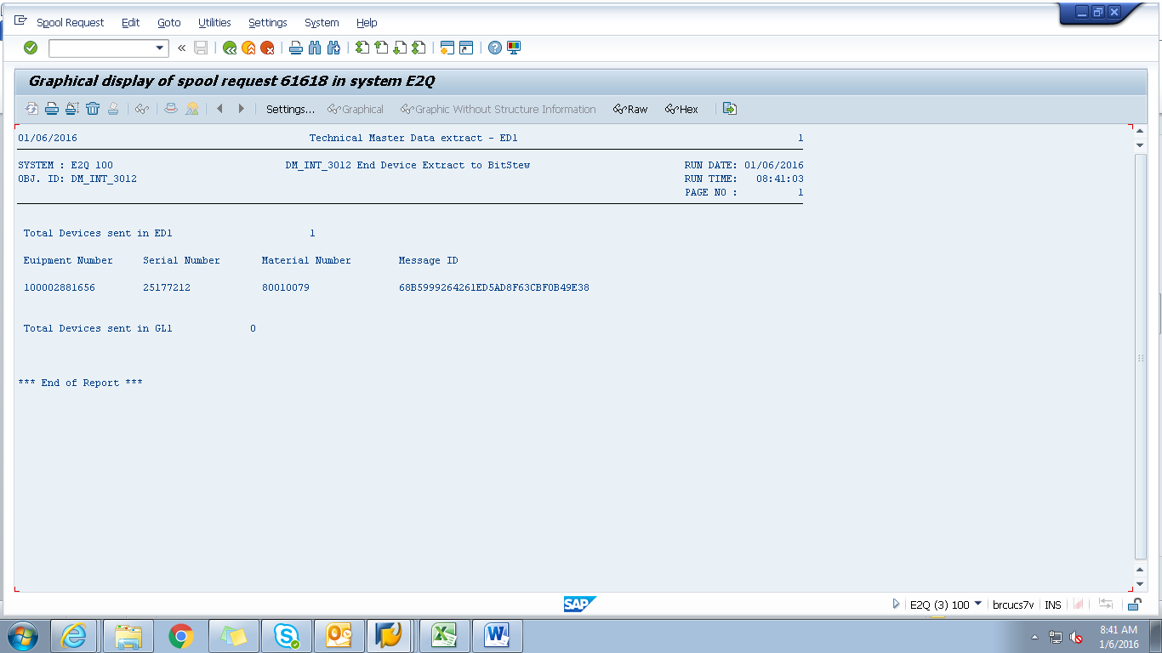

Payload
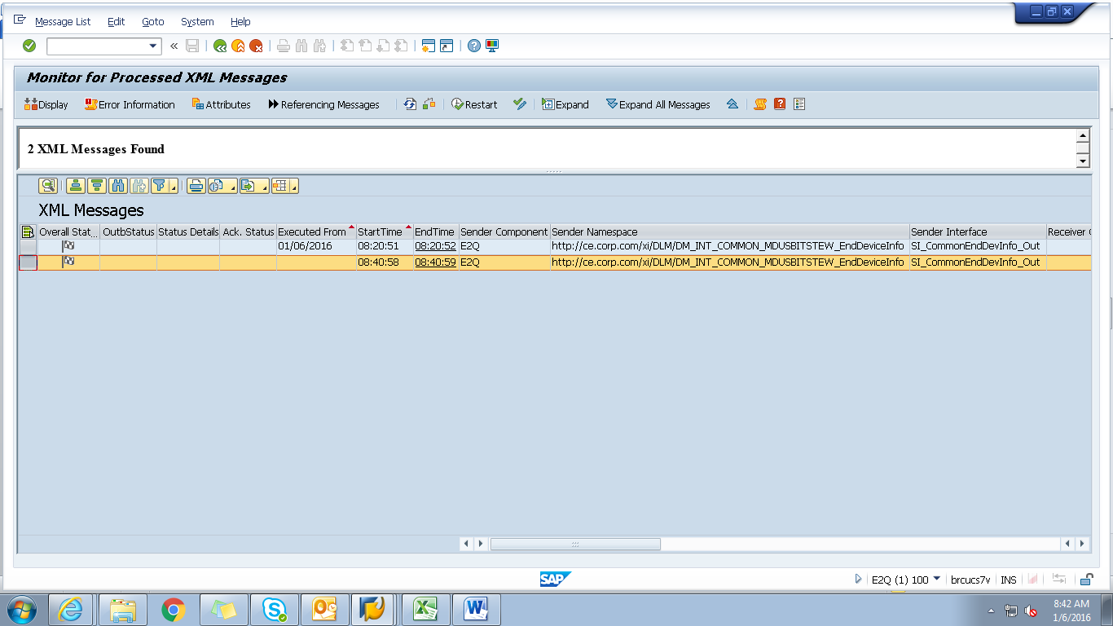

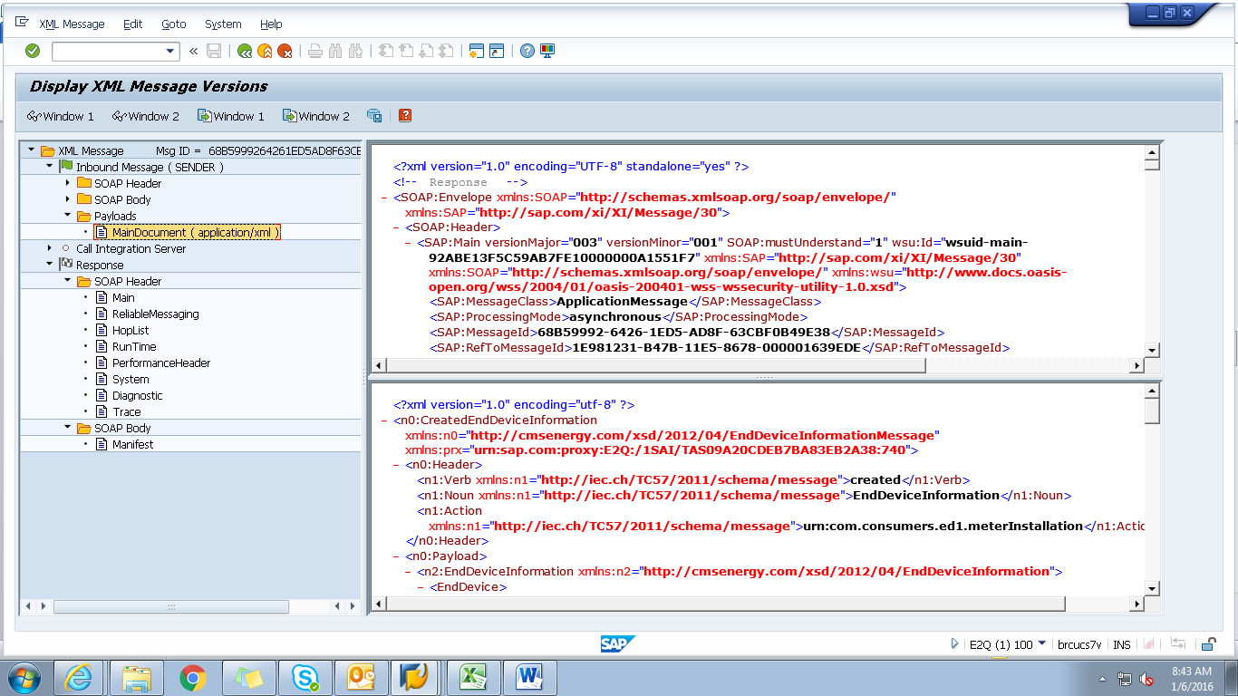
<?xml version="1.0" encoding="utf-8" ?>
- <n0:CreatedEndDeviceInformation xmlns:n0="http://cmsenergy.com/xsd/2012/04/EndDeviceInformationMessage" xmlns:prx="urn:sap.com:proxy:E2Q:/1SAI/TAS09A20CDEB7BA83EB2A38:740">
- <n0:Header>
<n1:Verb xmlns:n1="http://iec.ch/TC57/2011/schema/message">created</n1:Verb>
<n1:Noun xmlns:n1="http://iec.ch/TC57/2011/schema/message">EndDeviceInformation</n1:Noun>
<n1:Action xmlns:n1="http://iec.ch/TC57/2011/schema/message">urn:com.consumers.ed1.meterInstallation</n1:Action>
</n0:Header>
- <n0:Payload>
- <n2:EndDeviceInformation xmlns:n2="http://cmsenergy.com/xsd/2012/04/EndDeviceInformation">
- <EndDevice>
<mRID>000000000025177212</mRID>
<createdDateTime>2008-06-20T04:00:00Z</createdDateTime>
<installCode>5001966303</installCode>
<serialNumber>000000000080010079</serialNumber>
<type>02</type>
- <Customer>
- <CustomerAccounts>
- <CustomerBillingInfos>
<mRID>RES</mRID>
<type>A_250</type>
<startDate>2010-04-14T04:00:00Z</startDate>
<endDate>9999-12-31T05:00:00Z</endDate>
<readRoute>090510</readRoute>
<readCycle>05</readCycle>
</CustomerBillingInfos>
- <CustomerBillingInfos>
<mRID>RES</mRID>
<type>A_250</type>
<startDate>1900-01-01T05:00:00Z</startDate>
<endDate>2010-04-13T04:00:00Z</endDate>
<readRoute>090501</readRoute>
<readCycle>05</readCycle>
</CustomerBillingInfos>
</CustomerAccounts>
</Customer>
- <EndDeviceFunction>
<mRID>000000100002881656</mRID>
<name>MTR G 175/250 RMTC 1/8" Orifice</name>
</EndDeviceFunction>
- <UsagePoint>
<mRID>6002276613</mRID>
<name>OUT RIGHT</name>
<readCycle>05</readCycle>
<readRoute>090510</readRoute>
- <Installation>
<mRID>5001966303</mRID>
</Installation>
- <MeterServiceWorks>
<type>OMAR</type>
</MeterServiceWorks>
- <ServiceLocation>
<mRID>7002067785</mRID>
<name>0051</name>
- <mainAddress>
- <streetDetail>
<addressGeneral>15240 SILVER PKWY</addressGeneral>
<suiteNumber>#208</suiteNumber>
</streetDetail>
- <townDetail>
<code>48430-3485</code>
<name>FENTON</name>
<stateOrProvince>MI</stateOrProvince>
</townDetail>
</mainAddress>
</ServiceLocation>
</UsagePoint>
- <information>
<description>0000</description>
<title>AMCG</title>
</information>
- <status>
<reason>System Status</reason>
<value>Installed</value>
</status>
- <status>
<reason>User Status</reason>
<value>No Special test Available</value>
</status>
- <status>
<dateTime>2002-05-01T04:00:00Z</dateTime>
<value>Install Date</value>
</status>
- <status>
<reason>Certification Year</reason>
<value>2002</value>
</status>
- <status>
<reason>Certification Status</reason>
<value>No restriction</value>
</status>
</EndDevice>
</n2:EndDeviceInformation>
</n0:Payload>
</n0:CreatedEndDeviceInformation>

